**01/08/2024 JAVA-CSA0983**

**1.** **create generate class with another generate for the object of the generate class**

**PROGRAM:**

**public class Generate {**

**private String name;**

**public Generate(String name) {**

**this.name = name;**

**}**

**public class GeneratedObject {**

**private String name;**

**public GeneratedObject(String name) {**

**this.name = name;**

**}**

**public void printName() {**

**System.out.println("Generated Object Name: " + name);**

**}**

**}**

**public GeneratedObject generateObject() {**

**return new GeneratedObject(name);**

**}**

**public static void main(String[] args) {**

**Generate generate = new Generate("Example");**

**Generate.GeneratedObject generatedObject = generate.generateObject();**

**generatedObject.printName();**

**}**

**}**

**OUTPUT:**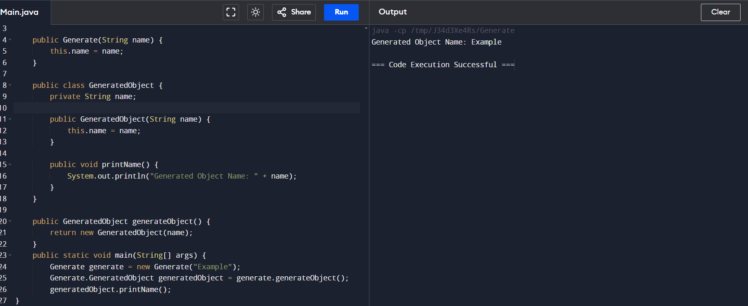

**2.** **write a java program to create generate method that take list of number and return the sum of all the event and odd number.**

**PROGRAM:**

**import java.util.ArrayList;**

**import java.util.List;**

**public class Main {**

**public static void main(String[] args) {**

**List<Integer> numbers = new ArrayList<>();**

**numbers.add(1);**

**numbers.add(2);**

**numbers.add(3);**

**numbers.add(4);**

**numbers.add(5);**

**numbers.add(6);**

**int[] sums = generateSum(numbers);**

**System.out.println("Sum of even numbers: " + sums[0]);**

**System.out.println("Sum of odd numbers: " + sums[1]);**

**}**

**public static int[] generateSum(List<Integer> numbers) {**

**int evenSum = 0;**

**int oddSum = 0;**

**for (int number : numbers) {**

**if (number % 2 == 0) {**

**evenSum += number;**

**} else {**

**oddSum += number;**

**}**

**}**

**return new int[]{evenSum, oddSum};**

**}**

**}**

**OUTPUT:**

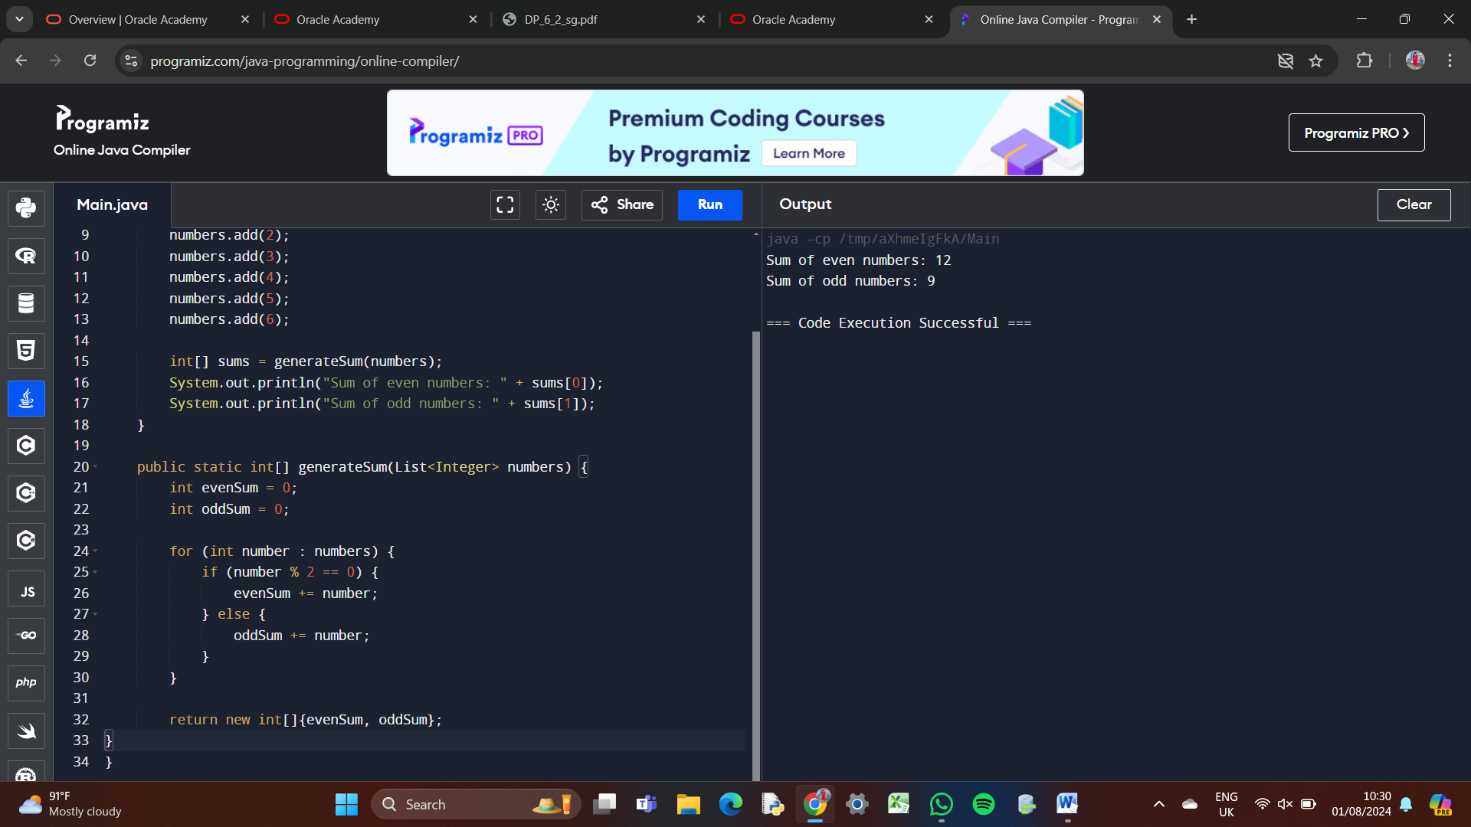

**3.** **write a java program to create genric method that takes the list of any typesb and a target element it return the index of first occurence of the target element in the list return-1 if the ytarget element cannot be found.**

**PROGRAM:**

**import java.util.ArrayList;**

**import java.util.List;**

**public class Main {**

**public static <T> int generateIndexOf(List<T> list,T target){**

**for(int i=0;i<list.size();i++){**

**if (list.get(i).equals(target)){**

**return i;**

**}**

**}**

**return -1;**

**}**

**public static void main(String[] args){**

**List<String> stringList=new ArrayList<>();**

**stringList.add("Apple");**

**stringList.add("Banana");**

**stringList.add("Cherry");**

**stringList.add("Date");**

**String targetString="Banana";**

**int resultString=generateIndexOf(stringList, targetString);**

**System.out.println("Index of "+targetString+": "+resultString);**

**}**

**}**

**OUTPUT;**

